**Lab 3**

1. Display your MAC address by 2 different ways.

# ipaddr

# ifconfig

​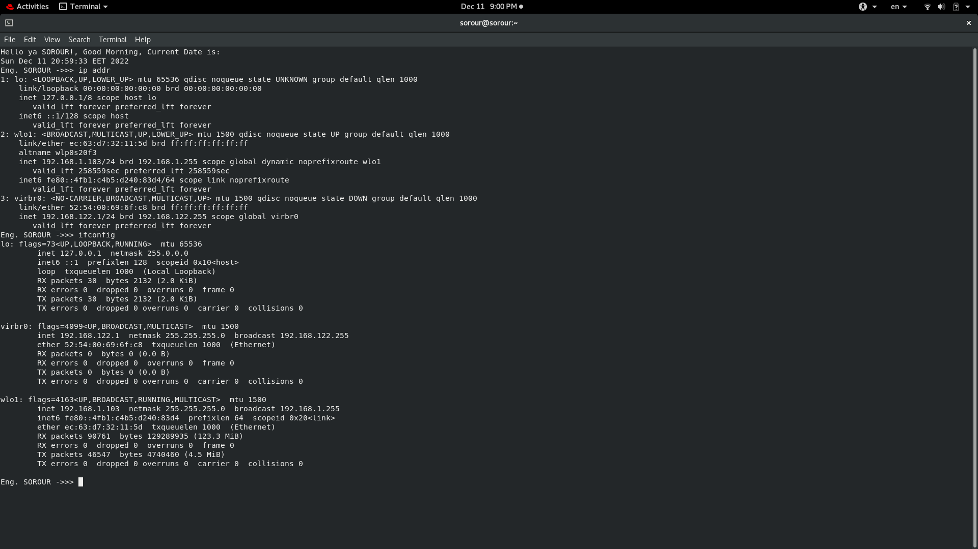​2. Display the network settings of all active interfaces.

# ifconfig

3. Display the network setting of all interfaces both active inactive.

# ifconfig-a

4. Bring your interface down.

# ifdown wlol

5. Configure your network card to have static IP.

# vi /etc/sysconfig/network-scripts/ifcfg-Ethernet_connection_1

# systemctl restart network.service​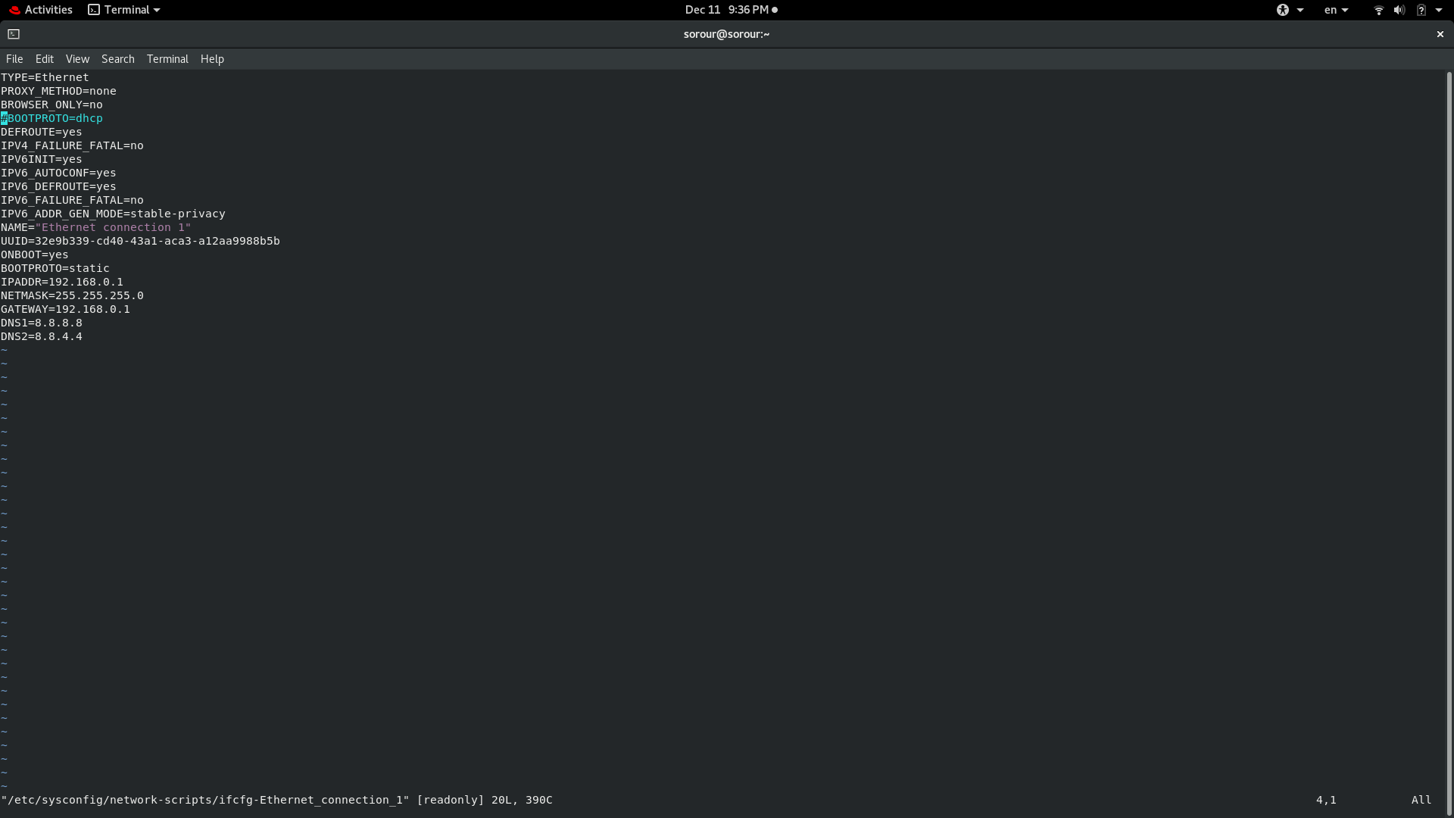​

6.Bring your interface up.

# Ifup wlol

7. Verify your network setting using ifconfig command

# ifconfig

8. Configure your network card to have dynamic IP using network

manager command.

# vi /etc/sysconfig/network-scripts/ifcfg-Ethernet_connection_1

​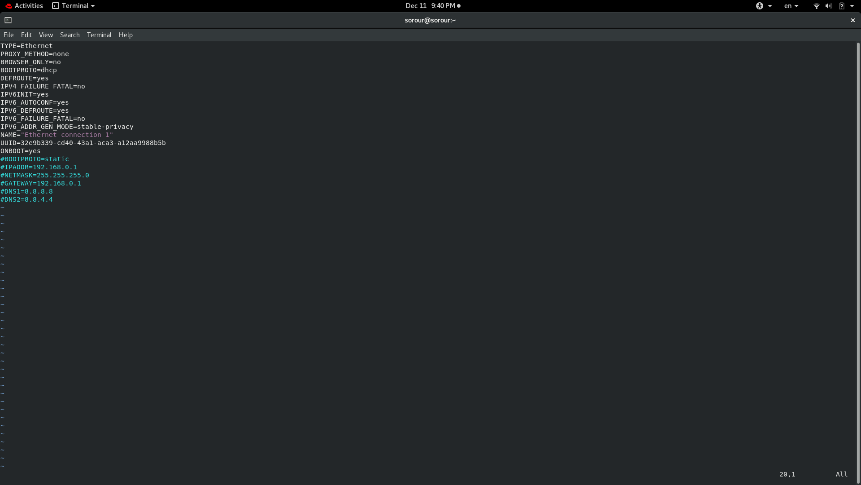​9. Check using ifconfig then check its configuration file.

# vi /etc/sysconfig/network

​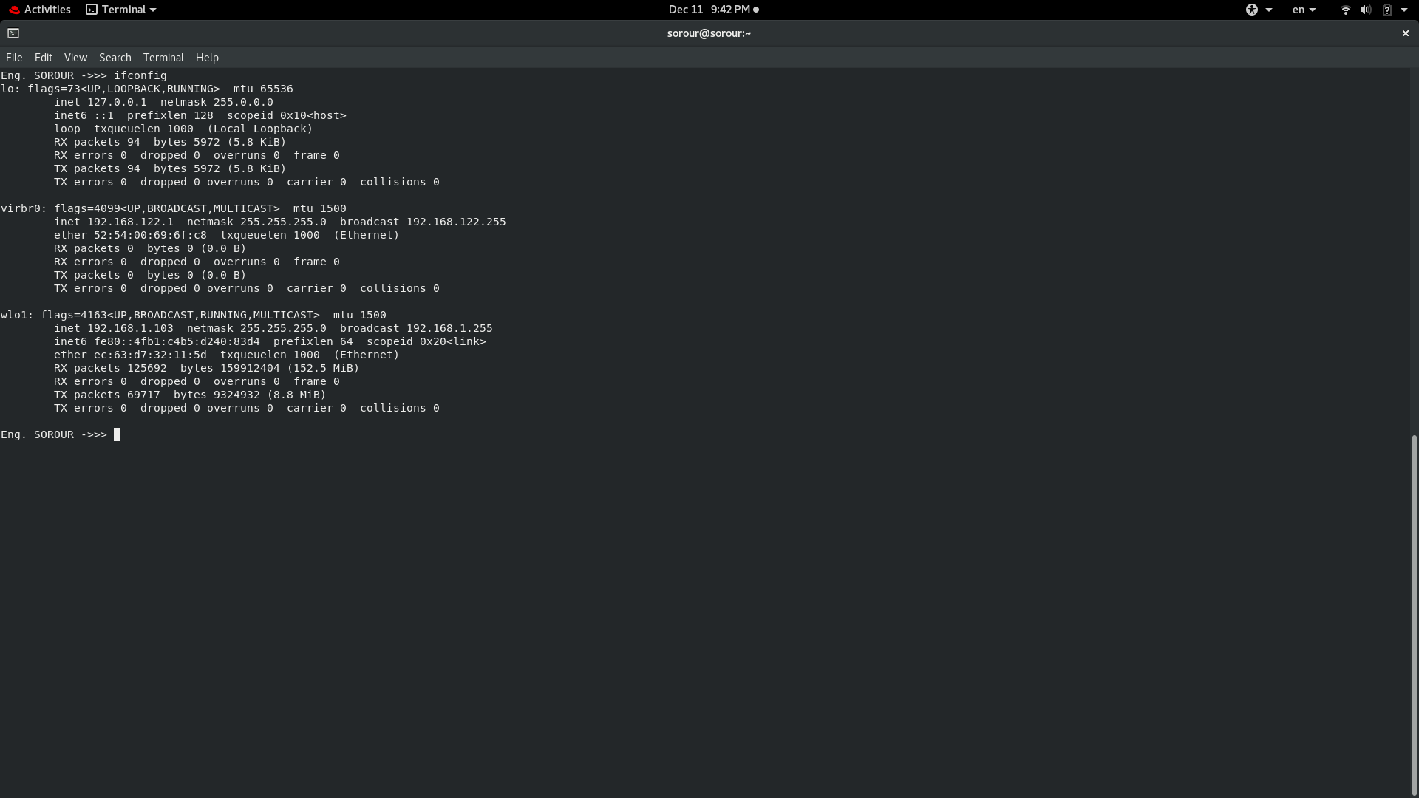​10. Reconfigure your network card using system-config-network

utility to have static IP.

# vi /etc/sysconfig/network-scripts/ifcfg-Ethernet_connection_1

11. Configure your network card to have 3 IPs and check that they

are all working using ifconfig command.

# sudo ip addr add 192.168.1.103/24 dev virbr0

# sudo ip addr add 192.168.1.103/20 dev virbr0

​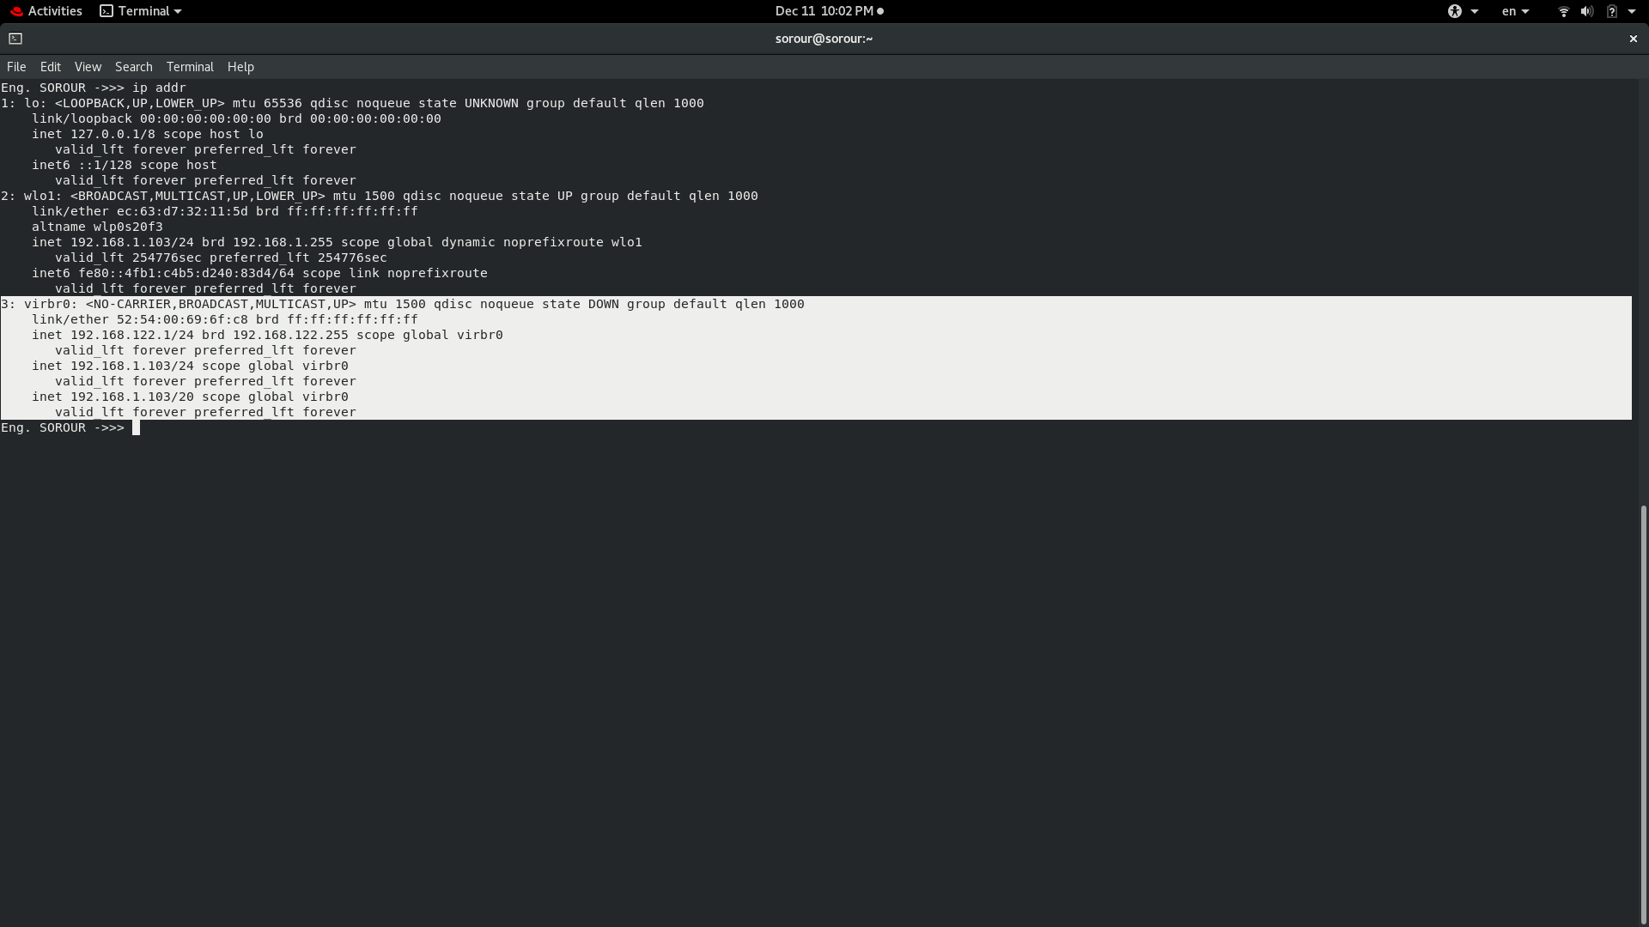​12. Change your host name in your global network file.

#vi /etc/hostname

​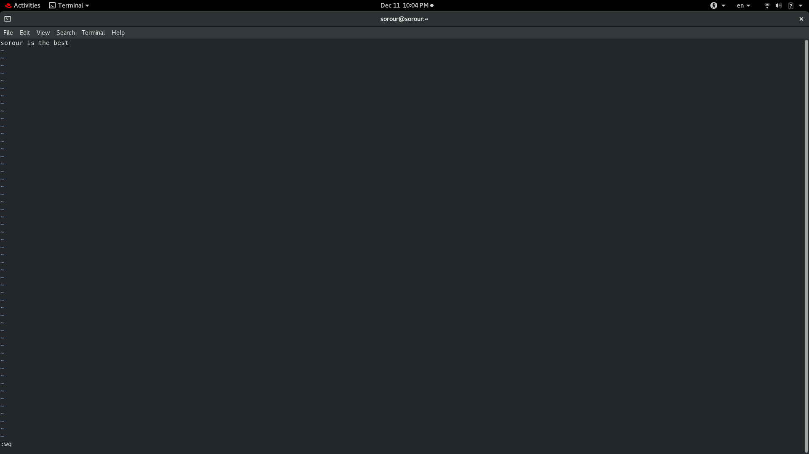​

13. Check the present value of proc/sys/net/ipv4/icmp_echo_ignore_all

0

14. It should be 0, change it to 1 which will prevent other hosts from successfully pinging your host while not affecting your ability to ping them.

# echo 1 > /proc/sys/net/ipv4/icmp_echo_ignore_all

15. Try to ping your colleague, let your colleague try to ping your host.

​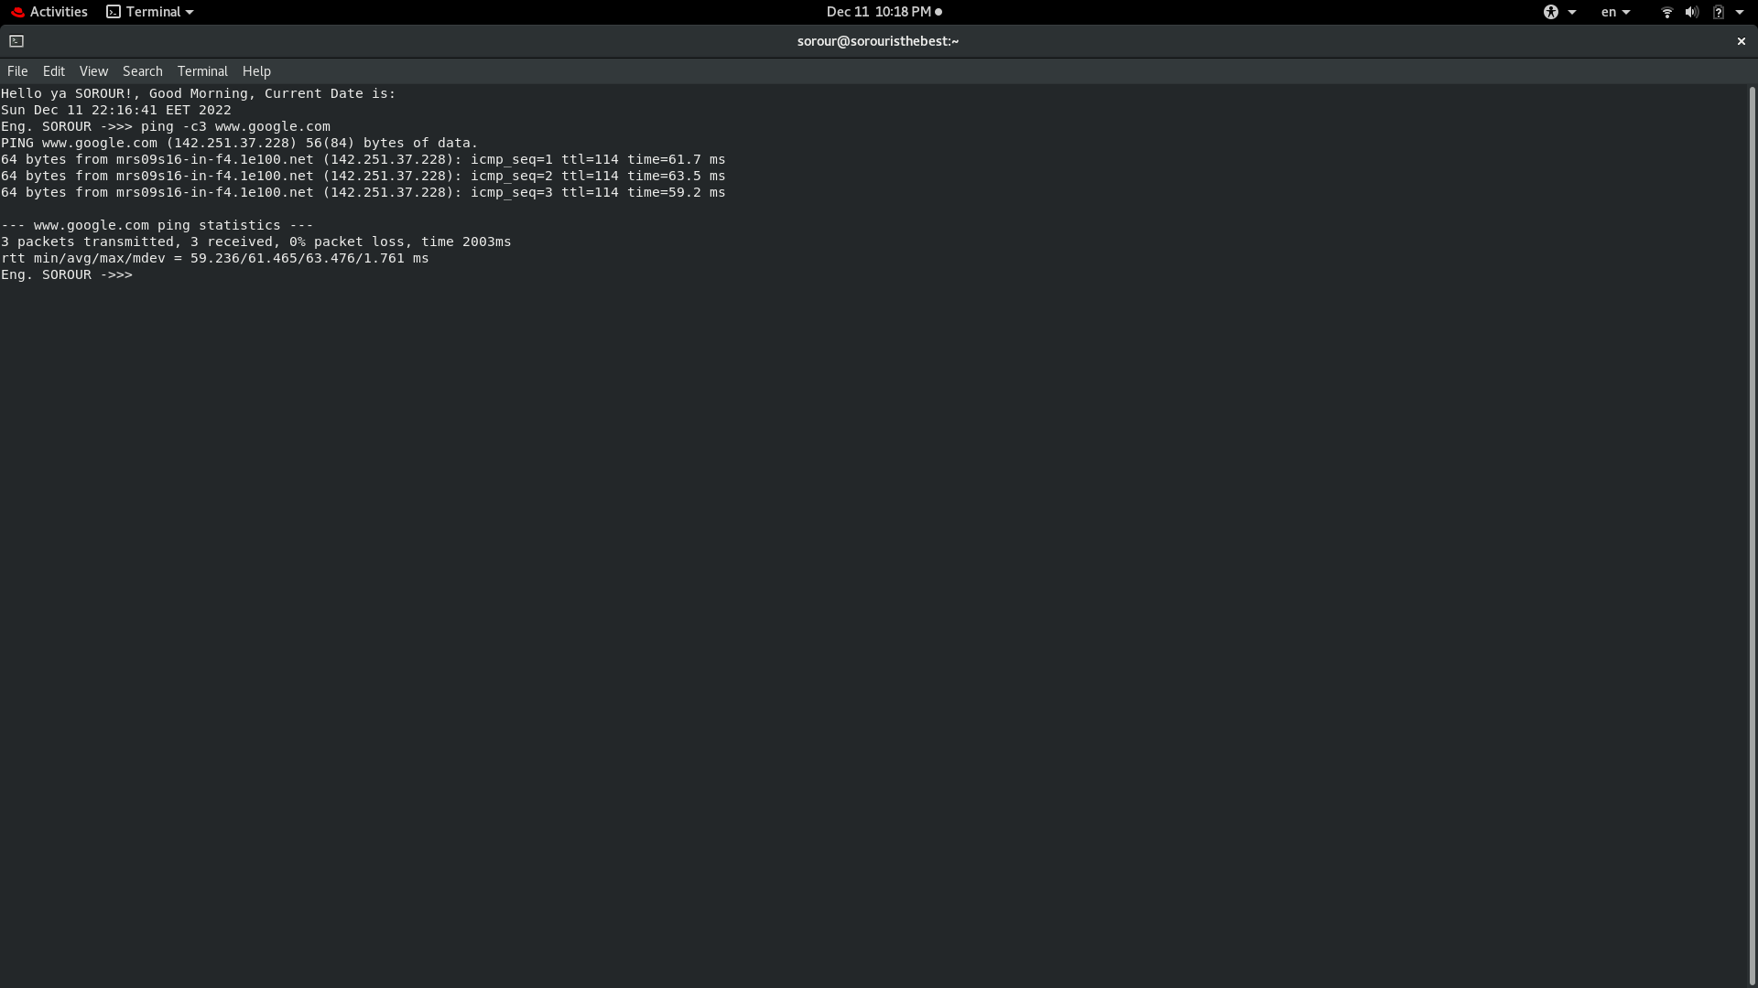​

Colleague failed to ping me

16. Reboot and try the last step. What happened? Why?

the value of /proc/sys/net/ipv4/icmp_echo_ignore_all returns to 0; as the change in proc is temporally not permanent because it is in RAM.

17. Edit /etc/sysctl.conf and put the following line at the bottom:

net.ipv4.icmp_echo_ignore_all=1

​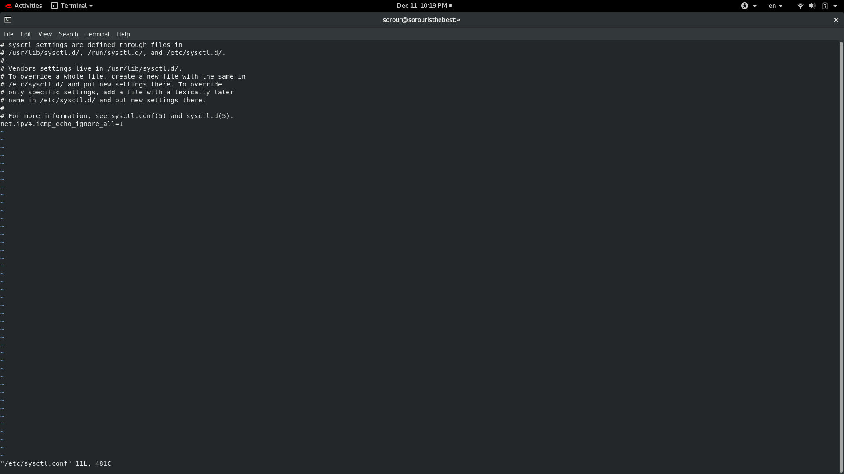​

18. Execute sysctl –p command.

done

19. Check the value of /proc/sys/net/ipv4/icmp_echo_ignore_all.

1

**Using yum**

20. Attempt to run the command gnuplot. You should find that it is not

installed.

Eng. SOROUR ->>> gnuplot

bash: gnuplot: command not found...

21. Search for the plotting packages.

Eng. SOROUR ->>> yum search gnuplot

22. Find out more information about the gunuplot package.

Eng. SOROUR ->>> yum info gnuplot

23. install gnuplot pakage

Eng. SOROUR ->>> sudo yum install gnuplot

24. Attempt to remove the gnuplot package, but say no

How many packages would be removed

Eng. SOROUR ->>> sudo yum remove gnuplot

3 pakage

25. Attempt to remove the gunplot-common package but say no

How many packages would be removed

Eng. SOROUR ->>> yum remove gnuplot-common

3 pakages

**Using rpm**

26. List all installed packages in your system.

Eng. SOROUR ->>> rpm -aq

27. View the files in the initscripts package

Eng. SOROUR ->>> rpm -ql initscripts

28. Get general information about bash rpm.

Eng. SOROUR ->>> rpm -q bash

29. Have the files from the pam package changed since it was installed.

Eng. SOROUR ->>> rpm -v pam

30. Which installed packages have gnome in their names?

Eng. SOROUR ->>> rpm -aq | grep "gnome"

31. Install any uninstalled package from RH Enterprise Linux cds Done

32. Search for software resemble the Photoshop software other than

Gimp and install it.

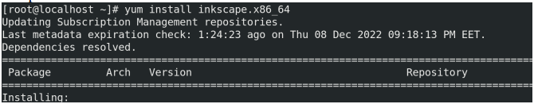

33. Create the file /etc/yum.repos.d/cdrom.repo to enable install from

the iso from the iso of Red Hat.

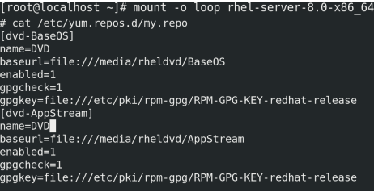

34. Try to install any package from the new repository

N/A